Advance Excel Assignment 6

1. The following are the basic parts of the Microsoft Excel Window:
2. Quick Access Toolbar
3. File Tab
4. Title Bar
5. Control Buttons
6. Menu Bar
7. Ribbon/Toolbar
8. Dialog Box Launcher
9. Name Box
10. Formula Bar
11. Scroll Bars
12. Spreadsheet Area
13. Leaf Bar
14. Column Bar
15. Row-Bar Cells
16. Cells
17. Status Bar
18. View Buttons
19. Zoom control

**1. Quick Access Toolbar**

This toolbar is located in the upper left corner of the screen. Its objective is to show the most frequently used Excel commands. We can customize this toolbar based on our preferred commands.

**2. File Tab**

Excel 2007's Office button has been replaced by the File tab. We can click it to **check the Backstage view**, where we can **open** or **save files, create new sheets, print sheets**, and perform other **file-related operations**.

**3. Title Bar**

The title bar of the spreadsheet is at the top of the window. It displays the **active document's name.**

**4. Control Buttons**

Control buttons are the symbols that are present in the **upper-right side** of the window, enabling us to change the **labels, minimize, maximize, share,** and **close the sheet.**

**5. Menu Bar**

Under the **diskette** or **save icon** or the **excel icon** (this will depend on the version of the program**), labels** or **bars** which enable changing the sheet which is shown. These are the menu bar and contain a **File, Insert, Page Layout, Formulas,** **Data, Review, View, Help,** and a **Search Bar** with a **light bulb** icon. These menus are divided into subcategories which simplify the distribution of information and analysis of calculations.

**6. Ribbon/Toolbar**

Each menu bar contains several different elements. On the selection of the menu, a sequence of command **options/icons** will show on a ribbon. For example, if we select the **"Home"** tab, we will see **cut, copy, paste, bold, italic, underline**, and **more** commands. In the same way; we can click on the **"Insert"** tab, we will see **tables, illustrations, additional, recommended graphics, graphics maps,** among others. On the other hand, if we select the **"Formulas"** option. **Insert functions, auto sum recently used, finances, logic, text, time, date,** etc.

**Ribbon/Toolbar** is a set of commands organized into three sections.

* **Tabs**  
  They are the Ribbon's top part, and they include groups of related commands. Ribbon tabs include **Home, Insert, Page Layout, Formula, Data.**
* **Groups**  
  They organize related commands; the name of each group is displayed below the Ribbon. For example, a set of commands related to fonts or a group of commands related to alignment, etc.
* **Commands**  
  They appear within each group, as previously stated.

**7. Dialog Box Launcher**

Dialog box launcher is a very little down arrow that is present in the **lower-right** corner of a command group on the Ribbon. By clicking on this arrow, we can explore more options related to the concerned group.

**8. Name box**

Show the location of the active cell, row, or column. We have the option of selecting multiple options.

**9. Formula Bar**

Formula bar permits us to observe, insert or edit the information/formula entered in the active cell.

**10. Scrollbars**

Scrollbars are the tools that enable us to **move the document's vertical** and **horizontal** views. We can activate this by clicking on the platform's internal bar or the arrows we have on the sides. Additionally, we can use the **mouse wheel** in order to automatically scroll up or down: or use the directional keys.

**11. Spreadsheet Area**

It is the place where we enter our data. It includes all the **rows, cells, columns**, and **built-in data** in the spreadsheet. We can use shortcuts to perform toolbar activities or formulas of **arithmetic operations (add, subtract, multiply, etc.)**. The insertion point is the blinking vertical bar known as the **"cursor."** It specifies the insertion location of the typing.

**12. Leaf Bar**

Leaf bar is present at the bottom of the spreadsheet, which says **sheet1** is shown. This sheet bar describes the spreadsheet which is currently being worked on. Using this, we can alternate a number of sheets or add a new one as per our convenience.

**13. Columns Bar**

Columns are a vertically ordered series of boxes across the full sheet. This column bar is located below the formula bar. The letters of the alphabet are used to label the columns. Begin with the letter **A** to **Z,** and then after **Z**, it will continue as **AA, AB,** and so on. The number of columns that can be used is limited to **16,384.**

**14. Rows Bar**

The row bar is the left part of the sheet where a sequence of numbers is expressed. Begin with number one (1), and further rows will be added as we move the pointer down. There are a total of **1,048,576** rows available.

**15. Cells**

Cells are those parallelepipeds that divide the spreadsheet into many pieces, separating rows and columns. A spreadsheet's first cell is represented by the first letter of the alphabet and the number one **(A1).**

**16. Status Bar**

The status bar is present at the bottom of the window that displays critical information. It also indicates whether something is incorrect or whether the document is ready to be printed or delivered.

This shows the result of the selected digits such as **sum, average, count, maximum, minimum,** etc.

By **right-clicking** on the **status bar**, we can configure the **status bar**. Any command from the specified list can be added or removed.

**17. View Buttons**

View buttons are a set of three buttons arranged at the left of the Zoom control, close the screen's right-bottom corner. We can see three different kinds of sheet views in Excel using this method.

* **Normal View:** - Normal view displays the Excel page in normal view.
* **Page Layout View:** - The Page Layout view shows the precise layout of an Excel page it will be printed.
* **Page Break View:** - This displays page break preview before printing.

**18. Zoom Control**

The zoom control is present at the lower-right side of the window. It enables us to ZOOM-IN or ZOOM-OUT a specific area of the spreadsheet. It is represented by magnifying icons with the symbols of maximizing (+) or minimizing (-).

The various modern versions contain a segment with the icons of more and less, as well as an element that separates the two alternatives, which permits us to manipulate them by clicking on any of these.

On the other side, it also explains in percentage how many times the document has been moved or approached. Microsoft Excel 2019 enables us to zoom out up to 10% and zoom up to 400%.

1. Various application of excel in industries:

* Data Entry and Storage.
* Performing Calculations.
* Data Analysis and Interpretation.
* Reporting and Visualizations.
* Accounting and Budgeting.

1. 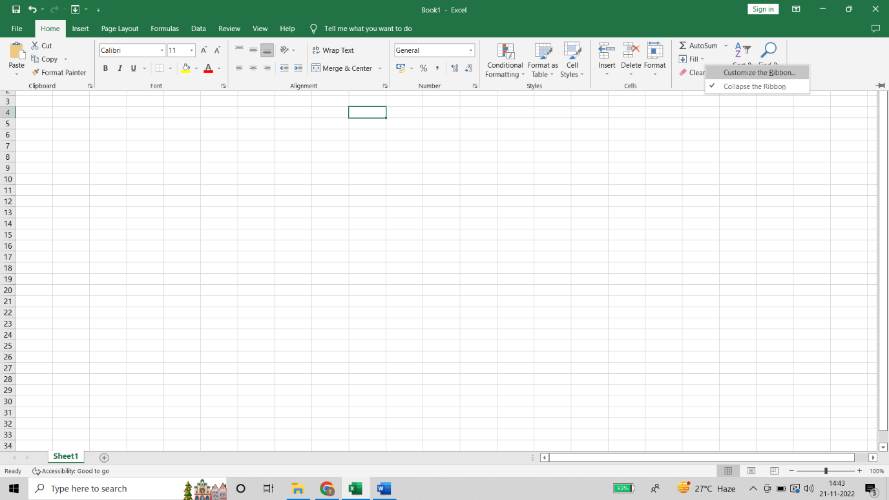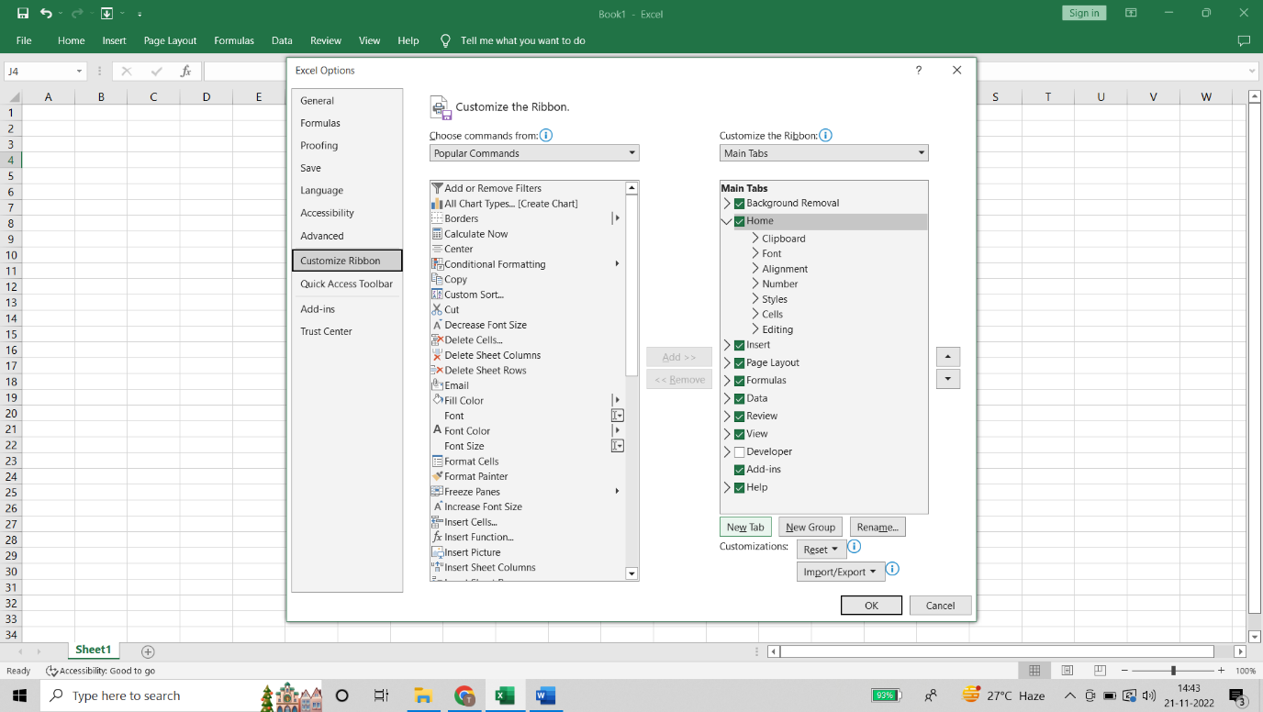

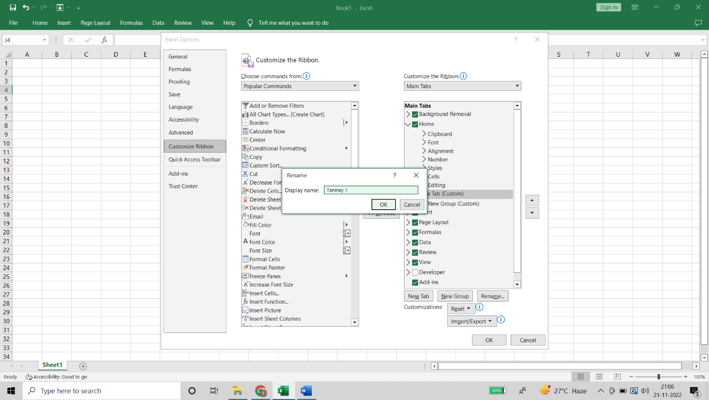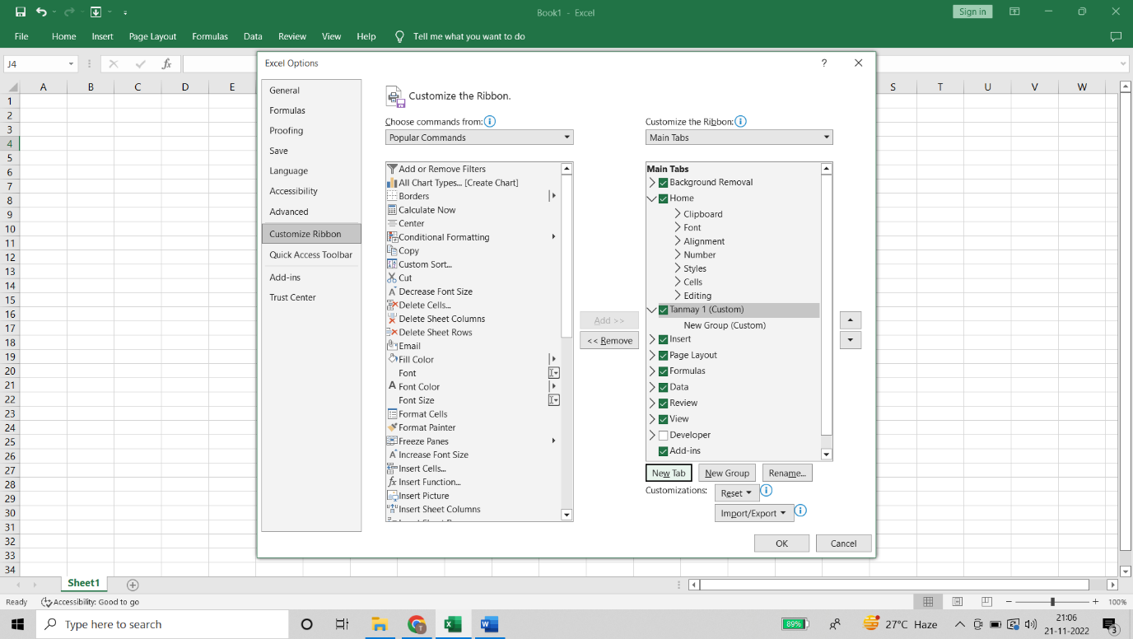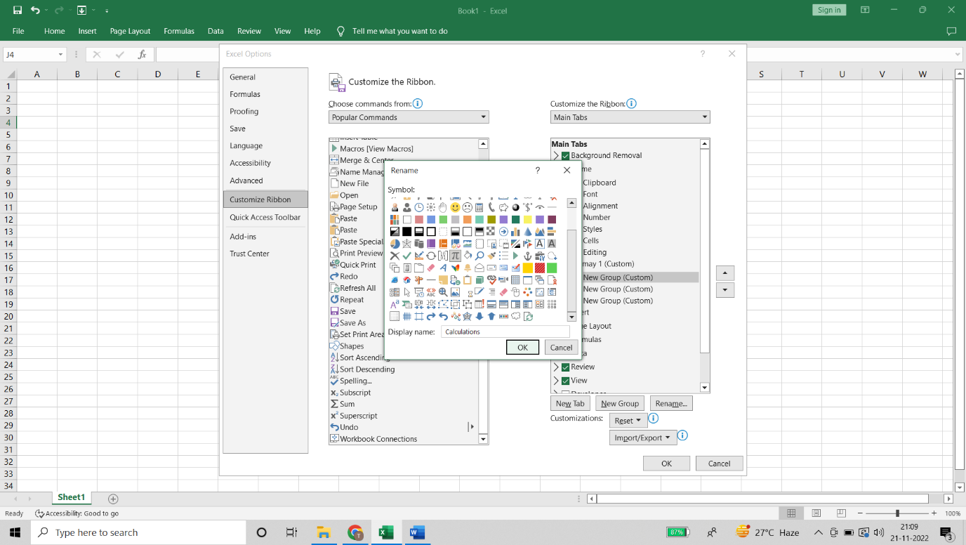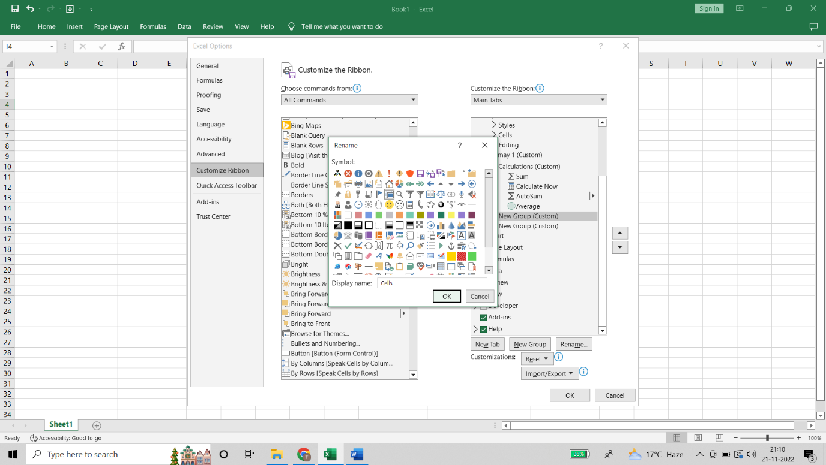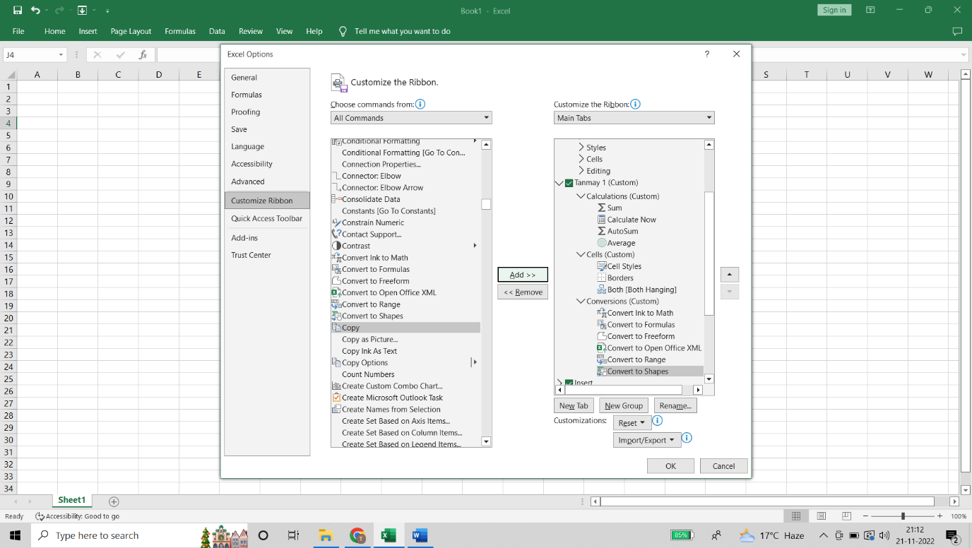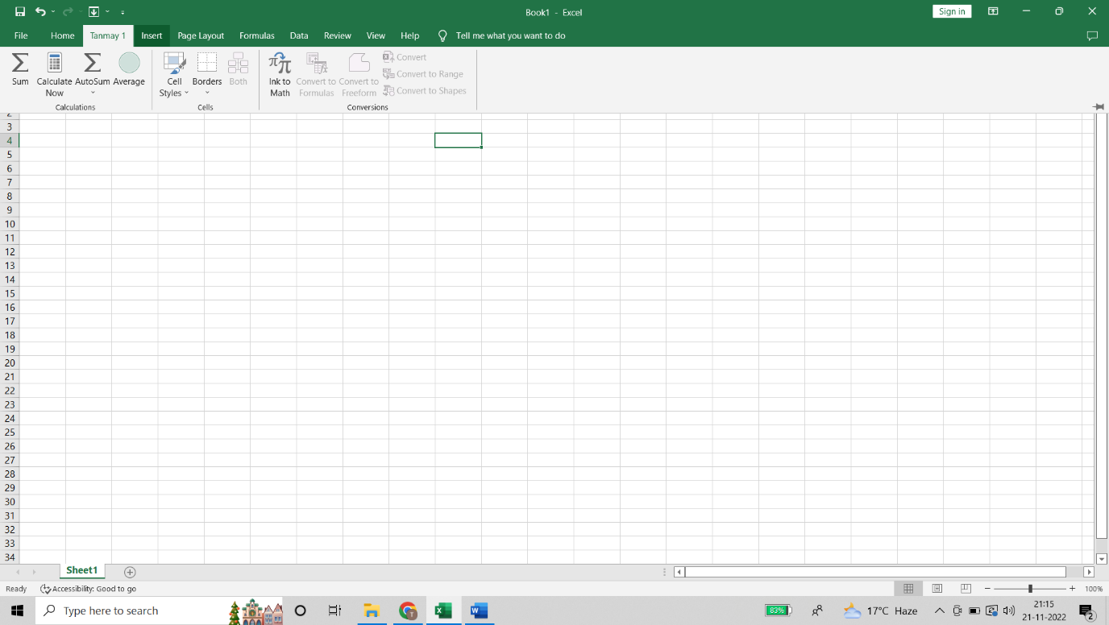

1. Shortcuts for formatting functions

|  |  |
| --- | --- |
| * Open the **Format Cells** dialog box. | * Ctrl+1 |
| * Format fonts in the **Format Cells** dialog box. | * Ctrl+Shift+F or Ctrl+Shift+P |
| * Edit the active cell and put the insertion point at the end of its contents. Or, if editing is turned off for the cell, move the insertion point into the formula bar. If editing a formula, toggle Point mode off or on so you can use the arrow keys to create a reference. | * F2 |
| * Insert a note. * Open and edit a cell note. | * Shift+F2 * Shift+F2 |
| * Insert a threaded comment. * Open and reply to a threaded comment. | * Ctrl+Shift+F2 * Ctrl+Shift+F2 |
| * Open the **Insert**dialog box to insert blank cells. | * Ctrl+Shift+Plus sign (+) |
| * Open the **Delete**dialog box to delete selected cells. | * Ctrl+Minus sign (-) |
| * Enter the current time. | * Ctrl+Shift+Colon (:) |
| * Enter the current date. | * Ctrl+Semicolon (;) |
| * Switch between displaying cell values or formulas in the worksheet. | * Ctrl+Grave accent (`) |
| * Copy a formula from the cell above the active cell into the cell or the formula bar. | * Ctrl+Apostrophe (') |
| * Move the selected cells. | * Ctrl+X |
| * Copy the selected cells. | * Ctrl+C |
| * Paste content at the insertion point, replacing any selection. | * Ctrl+V |
| * Open the **Paste Special** dialog box. | * Ctrl+Alt+V |
| * Italicize text or remove italic formatting. | * Ctrl+I or Ctrl+3 |
| * Bold text or remove bold formatting. | * Ctrl+B or Ctrl+2 |
| * Underline text or remove underline. | * Ctrl+U or Ctrl+4 |
| * Apply or remove strikethrough formatting. | * Ctrl+5 |
| * Switch between hiding objects, displaying objects, and displaying placeholders for objects. | * Ctrl+6 |
| * Apply an outline border to the selected cells. | * Ctrl+Shift+Ampersand sign (&) |
| * Remove the outline border from the selected cells. | * Ctrl+Shift+Underscore (_) |
| * Display or hide the outline symbols. | * Ctrl+8 |
| * Use the **Fill Down** command to copy the contents and format of the topmost cell of a selected range into the cells below. | * Ctrl+D |
| * Apply the **General**number format. | * Ctrl+Shift+Tilde sign (~) |
| * Apply the **Currency**format with two decimal places (negative numbers in parentheses). | * Ctrl+Shift+Dollar sign ($) |
| * Apply the **Percentage**format with no decimal places. | * Ctrl+Shift+Percent sign (%) |
| * Apply the **Scientific**number format with two decimal places. | * Ctrl+Shift+Caret sign (^) |
| * Apply the **Date**format with the day, month, and year. | * Ctrl+Shift+Number sign (#) |
| * Apply the **Time** format with the hour and minute, and AM or PM. | * Ctrl+Shift+At sign (@) |
| * Apply the **Number**format with two decimal places, thousands separator, and minus sign (-) for negative values. | * Ctrl+Shift+Exclamation point (!) |
| * Open the **Insert hyperlink** dialog box. | * Ctrl+K |
| * Check spelling in the active worksheet or selected range. | * F7 |
| * Display the **Quick Analysis** options for selected cells that contain data. | * Ctrl+Q |
| * Display the **Create Table** dialog box. | * Ctrl+L or Ctrl+T |
| * Open the **Workbook Statistics**dialog box. | * Ctrl+Shift+G |

1. Excel over others

* It’s easy to get started with Excel.
* The learning resources are very rich.
* You can do a lot of things with Excel: modelling, visualization, reports, dynamic charts, etc.
* It can help you understand the meaning of many operations before further learning other tools (such as Python and R).
* Data processing work under general office requirements
* Data management and storage of small and medium-sized companies
* Simple statistical analysis for students or teachers (such as analysis of variance, regression analysis, etc.)
* Combine Word and PowerPoint to create data analysis reports
* Assistant tool of data analysts
* Production of charts for some business magazines and newspapers (data visualization)

